**3D Models by** GabbyDesigner

Thank you for your business. Hope you're happy with your purchase .

**Project**

The project folder named **GabbyDesigner** contains all the files associated with the project. After opening the file tree hierarchy , you will find the following folders: **Meshes** (containing FBX and PREFAB models), **Animations**, **Materials**, **Textures**, and **Scene.** To add the model to your scene, open the Project Tab, then **Assets Folder>Meshes** click the **femaleIV.prefab** character and drag it to your scene.

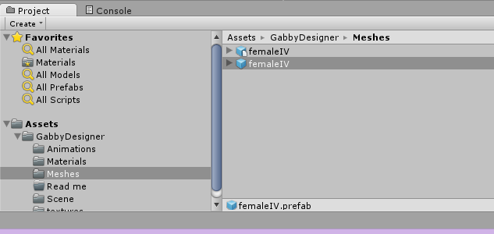

**Animations**

There are a total of 23 animations included in this package. These animations are set up using the **Animator_Controller** with the rig set to **Humanoid.** If you choose to change the animation type to **Legacy,** you will have to change the Rig Animation Type to Legacy in the Inspector Window .

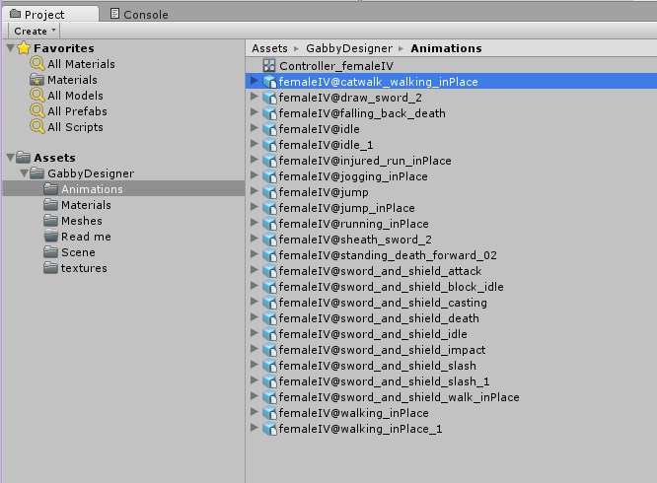

**Support**

If you have any questions or concerns, please email me at **gabbydesigner@gmail.com**. Enjoy!